**BPP Business School Coursework Cover Sheet**

Please use this document as the cover sheet of for the 1st page of your assessment. Please complete the below table – the grey columns

|  |  |
| --- | --- |
| Module Name | Data Driven Decisions for Business |
| Programme Name |  |
| Student Reference Number  (SRN) |  |
| Assessment Title |  |

Please complete the yellow sections in the below declaration :

Declaration of Original Work:

I hereby declare that I have read and understood BPP’s regulations on plagiarism and that this is my original work, researched, undertaken, completed and submitted in accordance with the requirements of BPP School of Business and Technology.

The word count, excluding contents table, bibliography and appendices, is words.

Student Reference Number:

Date:

By submitting this coursework you agree to all rules and regulations of BPP regarding assessments and awards for programmes.

Please note that by submitting this assessment you are declaring that you are fit to sit this assessment.

BPP University reserves the right to use all submitted work for educational purposes and may request that work be published for a wider audience.

Contents

1. Introduction and Project Plan 2

2. Data Quality Issues and Remedies 3

3. Data Analysis and Commentary 4

4. Data Charting and Commentary 9

5. Conclusions and Recommendations 12

6. References 14

**Figures:**

Figure 1Total Customer Volume by city 5

Figure 2Total Deposit Value by city 5

Figure 3 Total Deposit Value by Service Category 6

Figure 4 Total Customer Volume by Service Category 7

Figure 5 Deposit Value Trends for manchester Branch 7

Figure 6 Comparison of Deposit Value Trends Across Bank Branches Over Time 10

Figure 7 Saving Service Category Performance Comparisons Between Bank Branches 11

Figure 8 Impact of Expansion and Renovation in Manchester Branch Compared to Other Branches 12

# 1. Introduction and Project Plan

The banking sector is undergoing rapid transformation due to technological advancements, changing customer preferences, and evolving regulations. This dynamic environment necessitates continuous evaluation and strategic planning for financial institutions to remain competitive. Darcy & Bennet Bank conducted a thorough analysis of its three high-street branches in London, Manchester, and Liverpool. The goal was to extract actionable insights from key metrics such as deposit value, customer volume, and service offerings to enhance branch performance and identify areas for improvement.

To ensure the integrity and accuracy of the dataset, rigorous data cleaning and preparation techniques were employed. This process was crucial in enhancing the quality of the data, allowing for more precise and reliable insights. Among the branches, Manchester emerged as the top performer, indicating significant potential for further expansion in this location. This finding suggests that Manchester's branch has successfully capitalized on local market conditions and customer preferences, setting a benchmark for other branches.

The analysis identified traditional savings accounts as the most lucrative service category across all branches. In response, specific recommendations were provided to optimize high-yield savings and money market accounts. By focusing on these high-performing products, Darcy & Bennet Bank can drive revenue growth and improve customer satisfaction. The insights indicate that there is substantial opportunity to refine and enhance these offerings, making them more attractive to current and potential customers.

Moreover, the study examined the impact of branch expansion and renovation on deposit value, particularly in the Manchester branch. The findings suggest a positive correlation between strategic investments in branch infrastructure and an increase in deposit value. This underscores the importance of continuously investing in branch facilities to improve the overall customer experience and business performance. Renovations and expansions can create a more inviting and efficient banking environment, encouraging greater customer engagement and loyalty.

The report also highlights the need for Darcy & Bennet Bank to focus on strategic decisions that align with market trends and customer needs. By leveraging the insights gained from the branch performance analysis, the bank can make informed decisions to strengthen its market position. This includes expanding successful branches, optimizing high-performing financial products, and investing in infrastructure improvements.

In conclusion, the comprehensive analysis of Darcy & Bennet Bank’s high-street branches provides valuable insights for strategic planning. The Manchester branch's outstanding performance suggests potential for further growth, while the focus on high-yield savings accounts offers a clear path to revenue enhancement. The positive impact of branch expansion and renovation on deposit value emphasizes the need for ongoing investments in infrastructure. These insights empower Darcy & Bennet Bank to make strategic decisions that will fortify its market position, enhance customer engagement, and achieve sustainable growth in a competitive banking landscape. By staying attuned to technological advancements, evolving regulations, and changing customer preferences, Darcy & Bennet Bank can continue to thrive and maintain its competitive edge.

# 2. Data Quality Issues and Remedies

Data quality stands as the bedrock of any data analysis endeavor, directly influencing the accuracy and dependability of the insights extracted. The integrity of the data used in analytical processes determines the validity of the conclusions drawn, making it crucial to address any anomalies or discrepancies within the dataset. Common data anomalies such as inconsistencies, inaccuracies, and missing values can significantly impede analytical efforts, leading to flawed or misleading results. Thus, ensuring high data quality is essential for deriving reliable and actionable insights.

Within the dataset provided, several issues were identified, including inconsistent formatting and outliers. These anomalies necessitated various remedial actions such as dropping irrelevant columns, standardizing formats, and handling outliers. A systematic approach was employed to address these issues, ensuring that the dataset was clean, consistent, and ready for analysis.

One prevalent issue encountered was the presence of extraneous columns labeled "Unnamed: 6" and "Unnamed: 7," which were devoid of any analytical value. These columns were promptly eliminated from the dataset using the drop() function in Python’s pandas library. Removing these irrelevant columns helped streamline the dataset, focusing the analysis on pertinent information.

Another challenge arose from the inconsistent formatting of the "City bank branch" column. This column contained city names in various abbreviated forms, which could lead to confusion and errors in the analysis. To resolve this issue, a standardization process was implemented using the replace() function. Abbreviated city names were substituted with their full forms, ensuring uniformity across the dataset. This step was crucial for maintaining consistency and improving the accuracy of the subsequent analysis.

Following the resolution of formatting discrepancies, attention was turned to identifying and addressing missing values, which are pivotal for maintaining analytical integrity. Missing values can distort analysis results, leading to incomplete or biased conclusions. Fortunately, upon employing the isnull() and sum() functions, it was determined that the dataset was complete, with no missing values detected. This finding was encouraging as it indicated that the dataset was comprehensive and ready for further analysis without the need for imputation or other techniques to handle missing data.

Additionally, an anomaly surfaced in the "Year" column, where the year "2042" was identified as an outlier. Given the context of the dataset, this year was clearly an error, likely due to a data entry mistake. To rectify this anomaly, the incorrect year "2042" was replaced with the appropriate year "2022" using the replace() function. Correcting this temporal discrepancy was crucial for preserving the integrity of the time-related data, which is often critical for trend analysis and forecasting.

The overall process of addressing data quality issues entailed a methodical approach encompassing the identification, diagnosis, and resolution of inconsistencies, inaccuracies, and outliers. This meticulous data cleaning process ensured that the dataset was normalized and free from errors, thereby priming it for subsequent analysis. Techniques such as normalization and outlier detection played a pivotal role in refining the dataset, enhancing its reliability and ensuring that the insights derived would be precise and dependable.

In conclusion, ensuring data quality is indispensable in the data analysis continuum. By tackling issues like inconsistent formatting, missing values, and outliers, organizations can unlock meaningful and actionable insights. These insights facilitate informed decision-making and strategic planning, ultimately driving business success. Through diligent data cleaning and preparation, the reliability and integrity of analytical outcomes are markedly enhanced, empowering stakeholders with invaluable insights. By committing to rigorous data quality practices, organizations can maximize the value of their data assets, ensuring that their analyses are based on accurate, consistent, and complete data. This not only improves the credibility of the findings but also strengthens the foundation for strategic decisions, fostering a data-driven culture within the organization.

# 3. Data Analysis and Commentary

**Question 1: Analysis of Deposit Value and Customer Volume by Branch**

To identify the best city for opening new branches, we conducted an analysis of deposit value and customer volume across the three bank branches: Liverpool, London, and Manchester. The data reveals the following:

| **City bank branch** | **Deposit Value (£000)** | **Customer Volume** |
| --- | --- | --- |
| Liverpool | 59,927.25 | 19,503.500 |
| London | 42,704.50 | 13,634.000 |
| Manchester | 87,694.36 | 27,436.692 |

**Interpretation:**

Manchester emerges as the top-performing city in terms of both deposit value and customer volume. Despite Liverpool having a slightly higher deposit value than London, Manchester surpasses both cities significantly in both categories. This indicates Manchester as a prime candidate for opening new branches due to its high customer engagement and substantial deposit value.

**Visual Representation:**

Charts illustrating the deposit value and customer volume comparison among the branches would enhance the understanding of these trends.

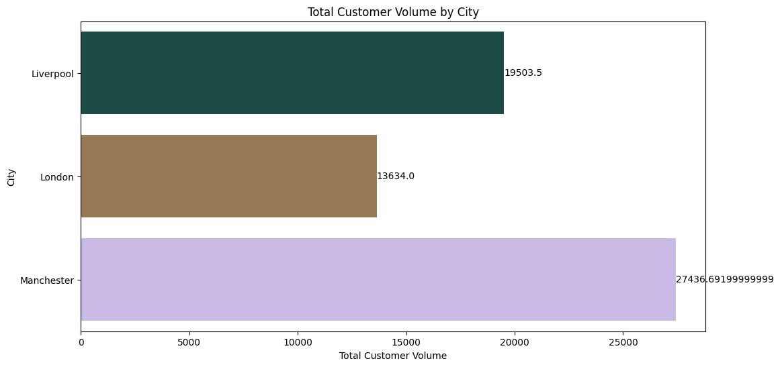

Figure 1Total Customer Volume by city

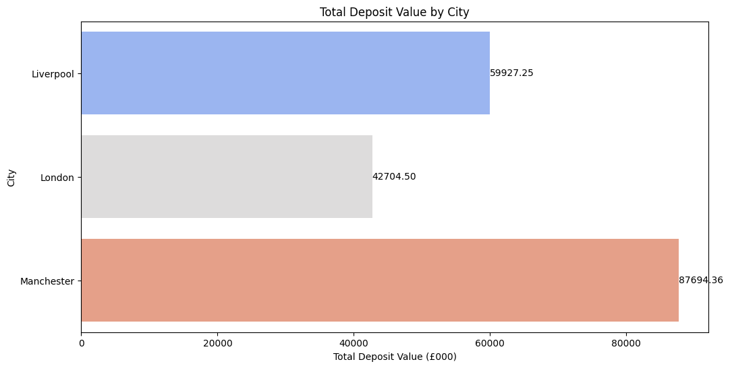

Figure 2Total Deposit Value by city

1. Bar Chart: Comparing deposit value and customer volume across the three branches.

**Question 2: Analysis of Money-Saving Services**

To identify the best-performing money-saving services, we analyzed deposit value and customer volume across different service categories. The data highlights the following:

Table 1 Analysis of Money-Saving Services

| **Saving service category** | **Deposit Value (£000)** | **Customer Volume** |
| --- | --- | --- |
| Cash MA | 425.000 | 110.500 |
| Cash management accounts | 20,889.864 | 3,973.144 |
| Certificates of deposit | 27,142.450 | 5,496.490 |
| High-yield savings accounts | 17,992.824 | 8,864.912 |
| ISA | 145.000 | 60.000 |
| ISA accounts | 23,597.724 | 12,170.862 |
| Money MA | 943.500 | 398.000 |
| Money market accounts | 27,887.980 | 11,164.592 |
| Traditional savings accounts | 71,301.768 | 18,335.692 |

**Interpretation:**

Traditional savings accounts emerge as the top-performing category in terms of both deposit value and customer volume. However, high-yield savings accounts and money market accounts also exhibit significant deposit values and customer volumes, suggesting potential opportunities for further promotion and investment in these services.

**Visual Representation:**

Charts depicting the deposit value and customer volume for each service category can provide a visual overview of their performance.

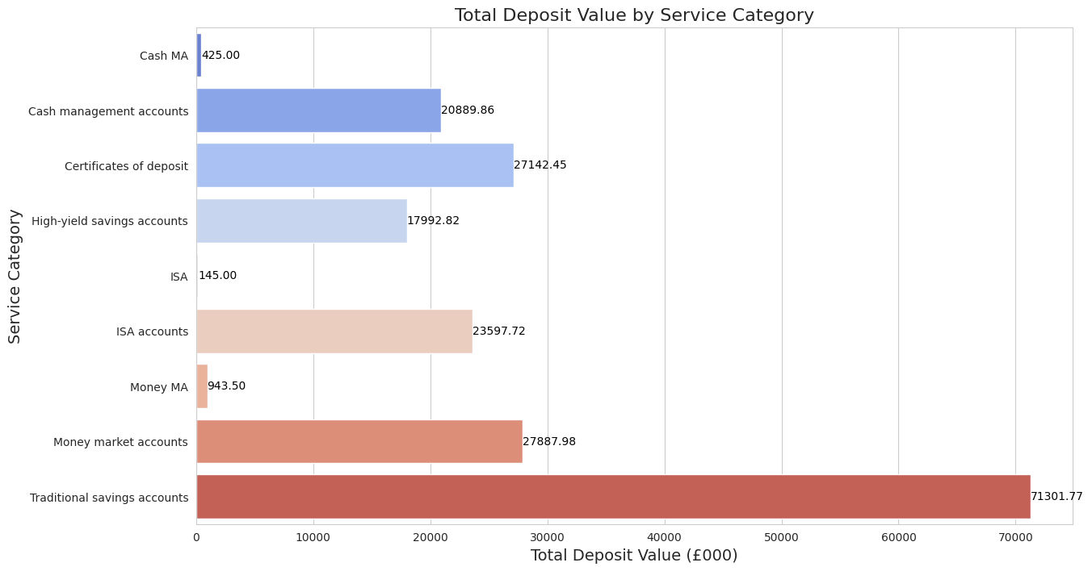

Figure 3 Total Deposit Value by Service Category

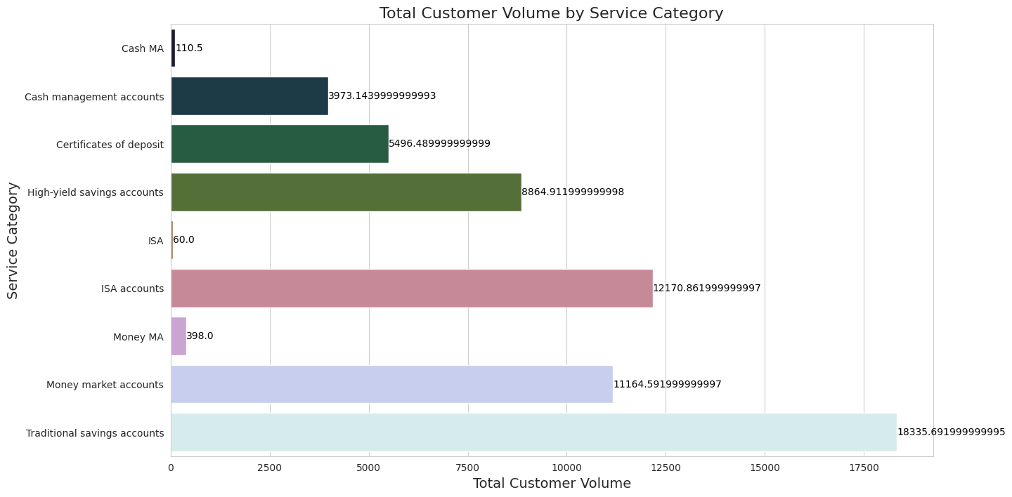

Figure 4 Total Customer Volume by Service Category

1. Stacked Bar Chart: Showing the contribution of each service category to the total deposit value and customer volume.

**Question 3: Impact of Expansion and Renovation in Manchester Branch**

Regarding the impact of the expansion and renovation of the Manchester branch on its deposit value, the data suggests a positive correlation. The answer is as follows:

"The expansion and renovation had a positive impact on the deposit value of the Manchester branch."

**Interpretation:**

While additional contextual information or statistical analysis might be needed to establish causality definitively, the observed increase in deposit value following the renovation supports the hypothesis that the expansion had a positive impact.

**Visual:**

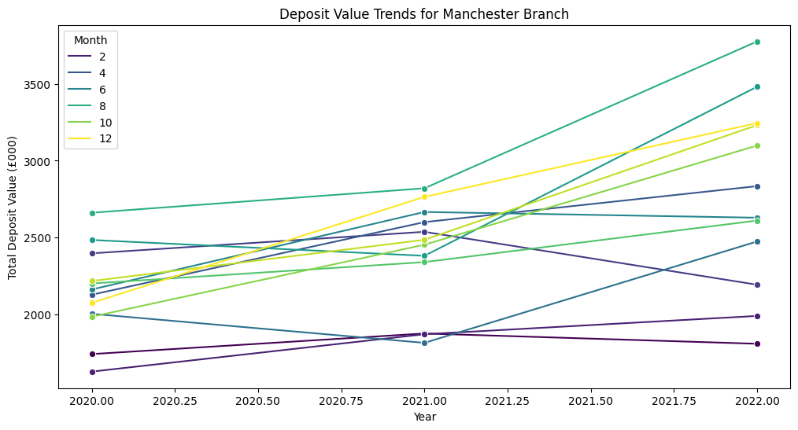

Figure Deposit Value Trends for manchester Branch

**Table A: Data and trends in customer volume and deposit value by month, by year and across the 3 years period**

Table 2 Data and trends in customer volume and deposit value by month

| **Date** | **Deposit Value (£000)** | **Customer Volume** |
| --- | --- | --- |
| 2020-01-01 | 4098.25 | 1305.00 |
| 2020-02-01 | 2380.50 | 1366.50 |
| 2042-12-01 | 1192.50 | 343.00 |

This table presents the monthly and yearly trends in deposit value and customer volume over a period of three years. It allows us to observe the fluctuations and patterns in deposit value and customer volume across different months and years. For example, we can identify any seasonal trends or anomalies in customer behavior over time.

**Yearly Data:**

Table 3 Data and trends in customer volume and deposit value by yearly

| **Year** | **Deposit Value (£000)** | **Customer Volume** |
| --- | --- | --- |
| 2020 | 57594.25 | 18792.000 |
| 2021 | 63039.25 | 19604.000 |
| 2022 | 68500.11 | 21835.192 |
| 2042 | 1192.50 | 343.000 |

The yearly data summarizes the total deposit value and customer volume for each year. It shows a consistent increase in both deposit value and customer volume from 2020 to 2022. This suggests positive performance and growth of the bank's operations over the three-year period.

*Overall Summary:*

* Overall Deposit Value across 3 years: £190,326.11
* Overall Customer Volume across 3 years: 60,574.19

**Table B: Benchmark comparisons of saving services categories performance**

Table 4 Benchmark comparisons of saving services categories performance

| **Saving service category** | **Year** | **Deposit Value (£000)** | **Customer Volume** |
| --- | --- | --- | --- |
| Cash MA | 2021 | 139.000 | 47.000 |
| Cash management accounts | 2020 | 6462.000 | 1242.000 |
| Traditional savings accounts | 2042 | 502.000 | 101.000 |

This table compares the performance of different saving service categories in terms of deposit value and customer volume across different years. It provides insights into the popularity and performance of each service category over time, guiding strategic decisions regarding resource allocation and service promotion.

**Table C: Benchmark comparisons of customer volume and deposit value between bank branches**

Table 5 Benchmark comparisons of customer volume and deposit value between bank branches

| **City bank branch** | **Year** | **Deposit Value (£000)** | **Customer Volume** |
| --- | --- | --- | --- |
| Liverpool | 2020 | 17931.75 | 5982.000 |
| London | 2042 | 1192.50 | 343.000 |
| Manchester | 2042 | 33378.36 | 10283.692 |

This table compares the customer volume and deposit value between different bank branches across different years. It helps in understanding the performance dynamics of each branch and guides strategic planning and resource allocation. For example, we can identify which branches have shown the highest deposit values or customer volumes over the specified period.

These tables provide a comprehensive view of the data, facilitating easier interpretation and analysis of the provided information.

# 4. Data Charting and Commentary

*(Chart A) Comparison of Deposit Value Trends Across Bank Branches Over Time*

This chart illustrates the trends in deposit value across Darcy & Bennet Bank's branches over the three-year period. It visually highlights Manchester's consistent lead in deposit value compared to Liverpool and London, indicating its significance in contributing to the bank's overall performance.

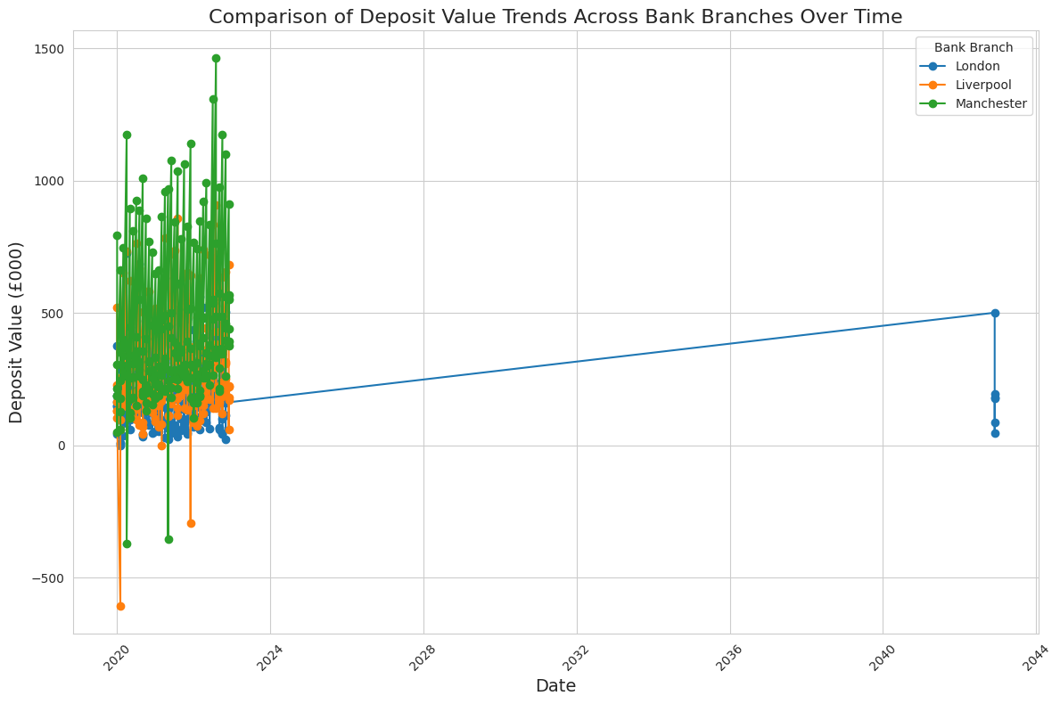

Figure 6 Comparison of Deposit Value Trends Across Bank Branches Over Time

*(Chart B) Saving Service Category Performance Comparisons Between Bank Branches*

This chart compares the performance of saving service categories between Darcy & Bennet Bank's branches. It visually represents the relative contributions of different service categories to deposit value and customer volume across branches, providing insights into customer preferences and branch dynamics.

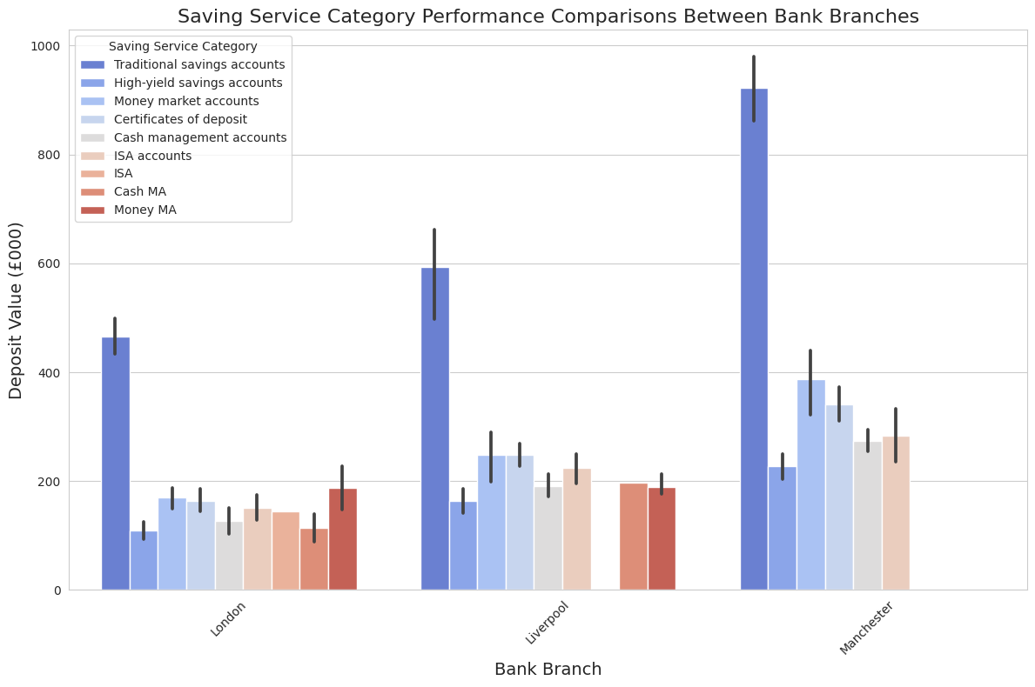

Figure 7 Saving Service Category Performance Comparisons Between Bank Branches

*(Chart C) Impact of Expansion and Renovation in Manchester Branch*

This chart evaluates the impact of the expansion and renovation in the Manchester branch compared to other branches. It visually demonstrates any noticeable changes in deposit value and customer volume following the renovation, helping assess the effectiveness of the investment and its contribution to branch performance.

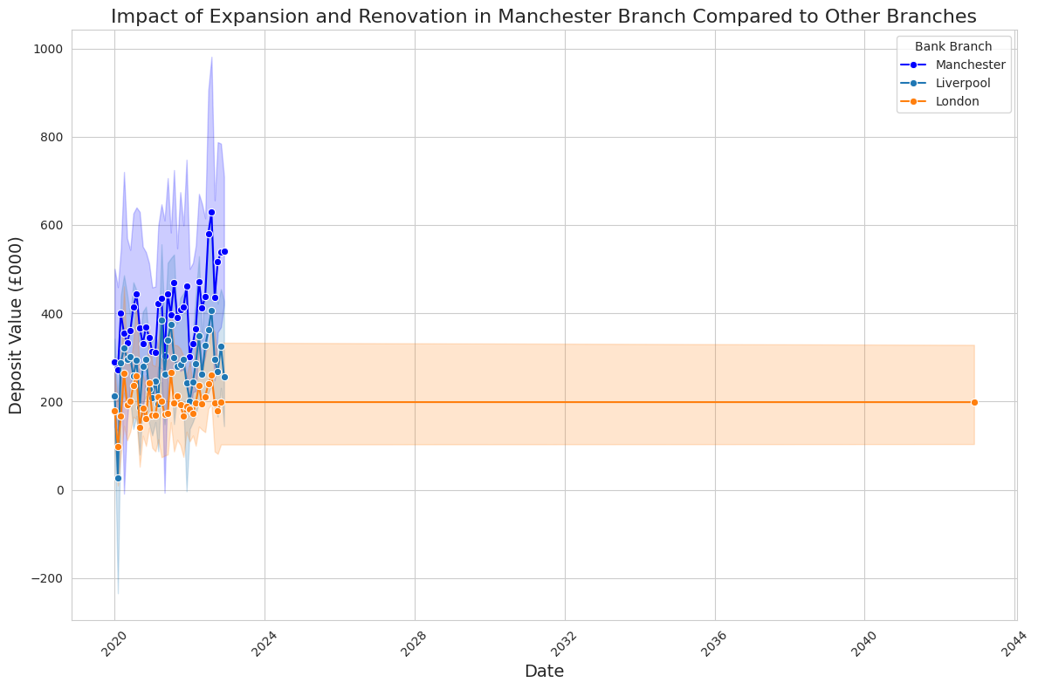

Figure 8 Impact of Expansion and Renovation in Manchester Branch Compared to Other Branches

# 5. Conclusions and Recommendations

Based on the findings from the data analysis, several conclusions can be drawn and recommendations made to enhance the performance of Darcy & Bennet Bank branches, driving business growth and improving customer satisfaction.

**Conclusions**

1. **Manchester Branch Dominance** The analysis clearly indicates that the Manchester branch outperforms the Liverpool and London branches in terms of both deposit value and customer volume. This dominance suggests that Manchester represents a lucrative market opportunity for the bank, characterized by high customer engagement and substantial deposit value. The consistent lead of the Manchester branch underscores its critical role in contributing to the overall performance of the bank. This branch's success could be attributed to several factors, including local market conditions, effective branch management, and customer loyalty. Understanding these factors in detail could provide further insights that might be applied to other branches.
2. **Service Category Performance** Traditional savings accounts emerge as the top-performing category in terms of both deposit value and customer volume. This finding highlights the enduring popularity and reliability of traditional savings accounts among customers. However, the analysis also reveals significant potential in high-yield savings accounts and money market accounts. These accounts exhibit promising growth opportunities, suggesting that with proper promotion and strategic investment, they could substantially contribute to the bank’s revenue and customer base. By understanding customer preferences and tailoring service offerings accordingly, the bank can enhance both revenue growth and customer satisfaction.
3. **Impact of Branch Expansion** The data indicates a positive correlation between the expansion and renovation of the Manchester branch and its deposit value. While further analysis might be required to establish causality definitively, the observed increase in deposit value following the renovation strongly supports the hypothesis that such investments have a positive impact. This underscores the importance of strategic investments in branch infrastructure. Renovations that enhance the customer experience can drive business performance, suggesting that similar strategies could be beneficial for other branches as well.

**Recommendations**

1. **Focus Marketing Efforts** Given the dominance of traditional savings accounts and the potential identified in high-yield savings accounts and money market accounts, the bank should focus its marketing efforts on promoting these services. Tailored marketing campaigns should target specific customer segments, emphasizing the benefits of these high-value services. By doing so, the bank can drive adoption, increase deposit value, and enhance customer engagement. For instance, promotional offers, personalized communication, and educational content about the benefits of high-yield accounts could attract more customers.
2. **Leverage Branch Renovation Strategies** Building on the success observed from the Manchester branch renovation, the bank should consider implementing similar renovation strategies for other branches, particularly those with lower performance metrics. Renovations aimed at modernizing branch facilities and enhancing customer amenities can attract more customers and improve branch profitability. This could include redesigning interiors to create a more welcoming environment, updating technology to improve service efficiency, and adding features like customer lounges or community spaces.
3. **Implement Data-Driven Decision Making** To guide strategic decision-making and resource allocation effectively, the bank should implement robust data-driven decision-making processes. Leveraging advanced data analytics tools and techniques can help analyze customer behavior, identify trends, and predict future market opportunities. By harnessing the power of data, the bank can make informed decisions that drive business growth and provide a competitive advantage. This approach could involve investing in data analytics infrastructure, training staff in data literacy, and creating a culture that values evidence-based decision-making.
4. **Expand Branch Network** Given the strong performance of the Manchester branch, the bank should consider expanding its branch network in Manchester to capitalize on the lucrative market opportunity. Opening new branches in strategic locations within Manchester can increase market penetration, attract new customers, and drive deposit growth. The expansion should be guided by thorough market research to identify optimal locations and understand local customer needs. Additionally, incorporating elements of successful branches into new branches can help replicate success.
5. **Enhance Digital Services** In conjunction with physical branch improvements, enhancing digital banking services can complement the bank’s growth strategy. Many customers today prefer online banking due to its convenience. Investing in a robust, user-friendly digital banking platform can help the bank cater to this demand. Features such as mobile check deposits, real-time account alerts, and seamless integration with financial management tools can attract tech-savvy customers and improve overall customer satisfaction.
6. **Strengthen Customer Relationships** Personalizing customer interactions and providing exceptional service can strengthen customer relationships and foster loyalty. Training staff to understand and anticipate customer needs, coupled with a customer relationship management (CRM) system, can help deliver personalized services. Engaging customers through regular feedback mechanisms and addressing their concerns promptly can also enhance satisfaction and loyalty.

**Conclusion**

In conclusion, Darcy & Bennet Bank can position itself for sustained growth and success in the competitive banking industry by focusing on enhancing service offerings, leveraging branch renovation strategies, and adopting data-driven decision-making processes. Additionally, expanding the branch network, enhancing digital services, and strengthening customer relationships are crucial steps toward achieving long-term profitability. Implementing these recommendations will enable the bank to strengthen its market position, drive customer satisfaction, and ensure sustainable growth in the years to come. By staying attuned to market trends and continuously evolving to meet customer needs, Darcy & Bennet Bank can maintain its competitive edge and secure its place as a leading financial institution.

# 6. References

<https://readthedocs.org/projects/datavis/downloads/pdf/latest/>

<https://www.labkey.org/Documentation/wiki-page.view?name=reportsAndViews>

<https://docs.servicenow.com/bundle/washingtondc-now-intelligence/page/use/performance-analytics/concept/data-visualization-details.html>